Fire!

Theatre Of The Mind Encounters

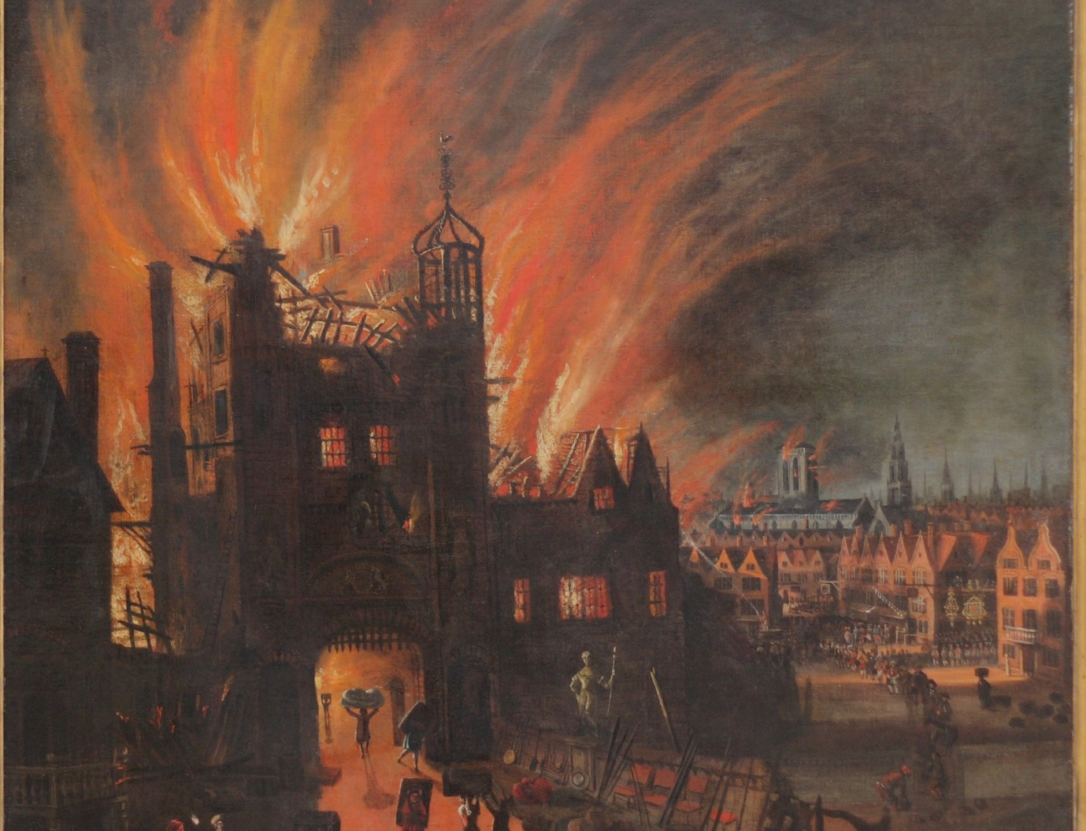

©PPM Games 2017
Artist: Billiam Babble, rights retained.
Billiam Babble / Inked Adventures (original art) © 2011 http://inkedadventures.com

Rolemaster ™ Copyright; 2002-2017 by Iron Crown Enterprises Ltd. All rights reserved. No reproductions without permission.

5e™ © 1995-2017 Wizards of the Coast LLC, a subsidiary of Hasbro, Inc. All Rights Reserved.

Other Theatre Of The Mind Encounters
TOM001 An Explosive Situation
TOM002 Evil Healers
TOM003 The Alchemist
TOM004 The Unjust Hanging
TOM005 The Foreign Princess
TOM006 The War Helm of Clanor
TOM007 The High Pass
TOM008 Fire!

Introduction
Atlan used to be an engineer but now he is High Priest of the Sun Worshipers and has built the ultimate holy weapon, on a roof top in the centre of town!
Theatre Of The Mind Encounters are short adventures, situations or encounters described purely in text. The setting description is kept to a minimum so they could be parachuted as easily into an Arabian Nights campaign just as easily as a Medieval European campaign.
These encounters are system neutral so no game stats, spells are explicitly mentioned and if a character’s profession is mentioned that should be taken to me the actual profession of the ‘living’ person not necessarily the character class of the same name if it exists. By that I mean if I mention a thief then I just mean someone who steals something not an NPC of the thief character class and all the associated skills and abilities. That does not mean that they are not of that class or profession. That is a choice for the DM/GM to make when preparing the encounter for his or her players.

The High Pass

Setting
This adventure can take place in any town anywhere if you don’t mind burning it to the ground should things get out of hand.
Atlan is an engineer who spent many years working in the far north where he witnessed the great melting of winter snow each spring and the majestic power of nature. Atlan also saw how snow and ice that were in permanent shadow never melted and endured all year round. Being dependent on melting ice for all their water Atlan soon realised how much power must be required to melt the snow and ice that stretches from horizon to horizon. In short Atlan came to worship the power of the sun.
Atlan has returned to civilisation and over the past year has been building machines, bigger and more impressive each time, that capture the power of the sun and concentrate it. These machines are a fusion of concave mirrors of beaten and polished steel, lenses of many sizes and mystic symbols and figures that Atlan sees when staring into the sun and then contemplates the afterimage with closed eyes.
In the past couple of months Atlan has removed the roof from a rented house in town and in the exposed attic has constructed a huge curved mirror and lense machine on wooden circular rails that can rotate to face the sun. Using ropes and pulleys Atlan can flex the mirror and cranks allow Atlan to move the lenses.
Atlan has demonstrated the machine by directing a wide beam of sunlight on to entire fields of crops to dry hay so it can be stacked and to create a concentrated beam to boil the water in a horse trough.
On the roof of the house other mirrors, like sails stand up and straight so Atlan can turn the machine to the north and use the reflected sunlight from the sails to power the sunbeams.
To most people in town Atlan is a harmless crank who can do some very clever things with mirrors. To those few that know Atlan; Atlan is becoming very worrying. Atlan’s religious zeal is going beyond devout and into dangerous territory. Atlan is talking about the sun scouring the unbeliever from the face of the world in a fiery new dawn.

Running Fire!
Fire! should open at dawn in the town. The people are awoken by Atlan stood on the flat roof of the townhouse proclaiming the new dawn will wipe all before him. Atlan repeats calls for people to listen to and heed the warning. Then as towns folk begin to gather Atlan starts to turn hand cranks and pull ropes to the sail mirrors. The curved mirror seems to flex as it slowly rotates and flaring red as it catpures the dawn light.
As the sun crests the horizon then there is a blinding flash of light and a beam leaps out from the mirror machine and strikes another temple or church in the town. First the temple glows in the artificial sunlight then suddenly the beam slices through the doors and walls burning and vaporising everything in its path.
Atlan seems filled with ecstasy and starts spinning his gears again and the beam starts to arc across town carving its way through buildings as it goes as Atlan seeks out the next church or temple to burn. All the time Atlan exhorts people to bow down to the rising sun. As the beam slings about it seems to get faster and more nimble.
Once two temples have been destroyed Atlan pulls on a sort of yoke or harness with ropes coming from each shoulder, elbow and hand. Then it appears the mirror machine is playing him like some kind of marionette. As Atlan’s arms and body move the mirrors flex, shift and the lenses move. Atlan is now wielding the sun beam to chase individual people and the targets are the priests in the crowd before below and any that give them shelter. If they hide in buildings then Atlan destroys the building.

Can the players save the town?
The relative power of the sun beam is up to the individual DM/GM. In a low powered game then tone down the damage and the speed with which Atlan can bring it to bear. In a more powerful game then I would suggest giving the beam the power of a lightning bolt but with associated burning damage.

Who is Atlan?
Atlan is really down to your own preference. These notes have made no reference to Atlan’s race or gender. You can have Atlan as a deranged dwarf or a screaming high priestess of the sun, the choice is yours.

Adding a Twist
In lower power games then having Atlan as a normal person means the sole threat comes from the machine and destroying that disarms the danger.
What if Atlan really is a priest of the sun god? There is no reason why he cannot be empowered with cleric, shaman or mystic magic to make Atlan an actual threat. Destroying the machine now only enrages Atlan and makes the characters the prime target.
Another potential twist is that Atlan is not really empowered by a sun god but is deluded and seduced by a demonic force and the slaying of the priests in the town are a blood sacrifice needed to open a gate. You can turn the tables on the player characters once they have engaged Atlan and destroyed the machine by having a demonic force step though a gate opened in the town square below.

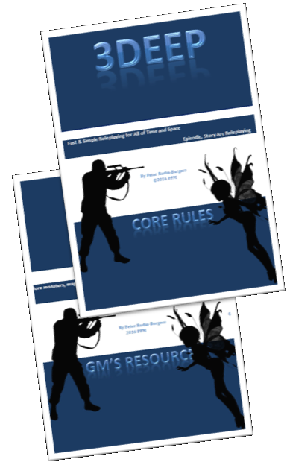
20% OFF!
The perfect partner to Theatre Of The Mind adventures is the light weight generic roleplaying game 3Deep.
Use this link and you will get 20% off the regular price of $4.99.
Now only $3.99
http://www.rpgnow.com/product/192087/3Deep-Role-Playing-Game-Core-Rulebook&discount=963d7354ef&src=TOM008

